Congress Bf the  States

20515

July 10, 2017

|  |  |
| --- | --- |
| The Honorable Tom Cole | The Honorable Rosa DeLauro |
| Chairman | Ranking Member |
| Appropriations Subcommittee on | Appropriations Subcommittee on |
| Labor-HHS& Education | Labor-HHS & Education |
| US House of Representatives | US House of Representatives |
| Washington, DC 20515 | Washington, DC 20515 |

Dear Chairman Cole and Ranking Member DeLauro:

As you work on the FY2018 Labor-HHS-Education Appropriations bill, we urge you to reject harmful cuts to programs that work to improve the health, financial security, and independence of millions of American seniors, people with disabilities, and their families. Specifically, we want to express our deep disappointment with the Trump Administration's recommendation to eliminate funding for the State Health Insurance Assistance Program (SHIP) and the Senior Community Service Employment Program (SCSEP). We urge you to reject those proposals and, instead, at least maintain funding for these critical initiatives.

# State Health Insurance Assistance Program (SHIP)

State Health Insurance Assistance Programs operate in every state, territory and the District of

Columbia. SHIPs provide essential information through enrollment clinics, "Welcome to Medicare" events, and informational seminars that help beneficiaries navigate Medicare, choose the plans that work best for them, and reduce their out-of-pocket costs. Older Americans and people with disabilities and their families rely on SHIPs, and our staff frequently refers constituents to SHIPs for assistance.

Through 3,300 state and local offices, more than 12,000 SHIP staff and volunteer counselors provide free one-on-one, personalized, and unbiased counseling to help millions of Americans understand the range of options they face and get the most out of their hard-earned Medicare benefits. At its current funding level of $47. I million—less than a dollar for every person enrolled in Medicare—it is an invaluable resource that must be maintained.

# Senior Community Service Employment Program (SCSEP)

The Senior Community Service Employment Program helps address the growing need of job training and labor force development for low-income Americans 55 and older who want to continue living independent and productive lives. The SCSEP currently serves 65,000 older workers across the country, helping older workers both develop new skills and contribute to their communities by working in schools, hospitals, senior centers, and other non-profit facilities. Older Americans often struggle to find jobs when unemployed, taking 40 weeks on average

PRINTED ON RECYCLED PAPER

2017

compared to 24 weeks for their younger counterparts. This period of long-term unemployment can have disastrous effects, both financially and emotionally. Coupled with a looming retirement savings crisis, where a majority of older Americans do not have nearly enough saved for retirement, it is crucial that we allow this program to continue as a lifeline for these workers.

Congress designed SCSEP to foster individual economic self-sufficiency and promote employment of SCSEP participants into unsubsidized jobs. As required by the Older Americans Act, 75 percent of SCSEP funds are used for wages for participants, who include veterans, individuals with disabilities, rural residents, and other most-in-need older Americans. Two-thirds of participants are women. Cuts to this program therefore directly harm these economically vulnerable Americans.

Again, we urge you to reject President Trump's proposal to slash SHIP and SCSEP funding. We thank you for your attention to our request.

Sincerely,

|  |  |
| --- | --- |
|  |  |
| n  E | chakowsky  BER OF CONGRESS |
|

Ted Deutch

|  |  |
| --- | --- |
| Doris Matsui | Jam e Raskin |
| MEMBER OF CONGRESS | MEMBER OF CONGRESS |

## MEMBER OF CONGRESS

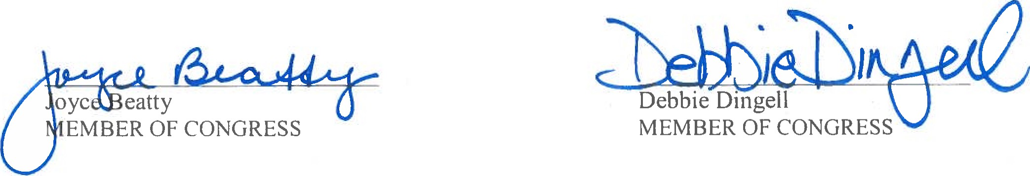

2017

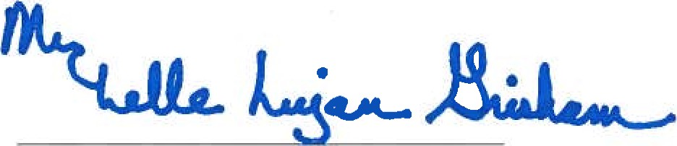

Michelle Lujan Grisham

## MEMBER OF CONGRESS

|  |  |  |  |
| --- | --- | --- | --- |
|  | |  |  |
| Sander L  MEMBE |  | CONGRESS | |



Eleanor Holmes Norton

## MEMBER OF CONGRESS

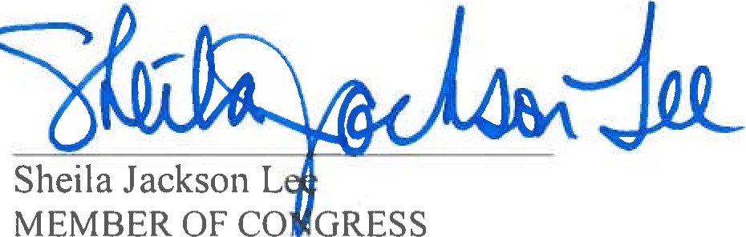

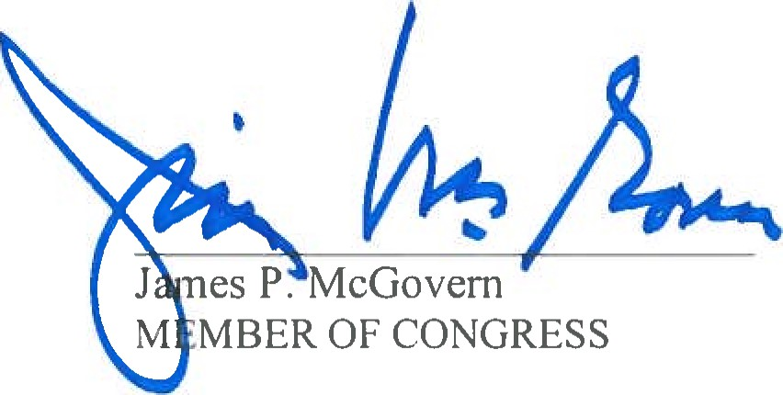

|  |  |  |
| --- | --- | --- |
|  |  |  |
| J | Conyers, Jr.  BER OF CONG ss | |

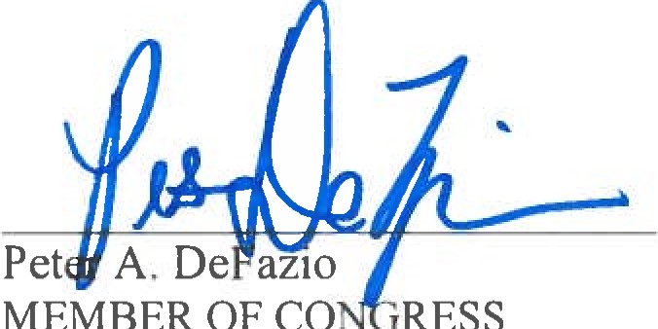

MEMBER

OF

CO,

RESS



## MEMBER OF CONGRESS

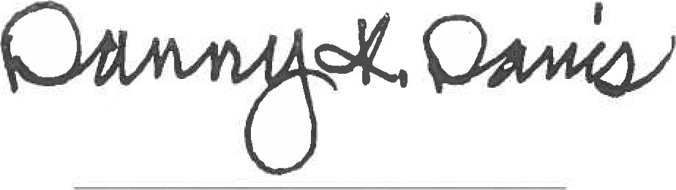

Danny K. Davis

## MEMBER OF CONGRESS



arbara

Lee

## MEMBER OF CONGRESS 7 MEMBER OF CONGRESS

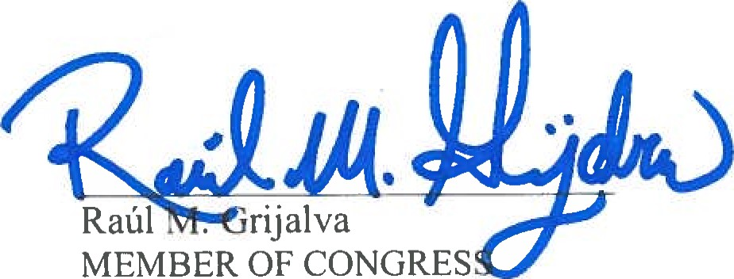Rick Lar en

|  |  |
| --- | --- |
| Daniel W. Lipinski | Kathy Castor |
| MEMBER OF CONGRESS | MEMBER OF CONGRESS |

## MEMBER OF CONGRESS

|  |  |
| --- | --- |
|  |  |
| Joe Courtney | |

## MEMBER OF CONGRESS

|  |  |  |  |
| --- | --- | --- | --- |
|  | |  |  |
| J | E | •e Speier  GRESS  BER OF | |

|  |  |  |
| --- | --- | --- |
|  |  |  |
| Keith | Ilison | |

## MEM ER

2017

 d..gN

Rick Nolan

## MEMBER OF CONGRESS

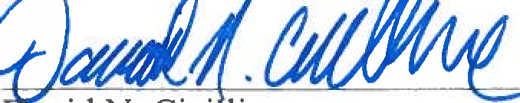avid N. Cici line

## MEMBER OF CONGRESS

Frederica Wilson nne Bonamici

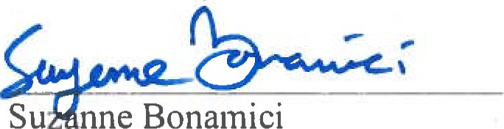

Su

|  |  |
| --- | --- |
| MEMBER OF CONGRESS | MEMBER OF CONGRESS |

|  |  |
| --- | --- |
| Charlie Crist | Vicente Gonzalez |
| MEMBER OF CONGRESS | MEMBER OF CONGRESS |

 Brendan F. Boyle



Mark

Pocan

|  |  |
| --- | --- |
| MEMBER OF CONGRESS | MEMBER OF CONGRESS |

