Günittd StattB Stnatt

WASHINGTON, DC 20510

May 25, 2017

|  |  |
| --- | --- |
| The Honorable Roy Blunt | The Honorable Patty Murray |
| Chairman | Ranking Member |
| Subcommittee on Labor, Health and Human | Subcommittee on Labor, Health and Human |
| Services, Education and Related Agencies | Services, Education and Related Agencies |
| Committee on Appropriations | Committee on Appropriations |
| 135 Dirksen Senate Office Building | 156 Dirksen Senate Office Building |
| Washington, DC 20510 | Washington, DC 20510 |

Dear Chairman Blunt and Ranking Member Murray,

As you begin work on the FY 2018 Labor, Health and Human Services, and Education

Appropriations bill, we urge you to include $52.1 million for the State Health Insurance

Assistance Program (SHIP). This will allow SHIPs to continue their important role in serving as a trusted source of independent advice that helps seniors, people with disabilities and their families navigate Medicare, choose the plans that work best for them, and reduce their out-ofpocket costs.

State Health Insurance Assistance Programs operate in every state, territory and the District of Columbia. SHIPs provide essential information through enrollment clinics, "Welcome to Medicare" events, and informational seminars. With 3,300 state and local offices, they provide free one-on-one, personalized, and unbiased counseling to help individuals understand the range of options they face and get the most of their Medicare benefits. Last year, SHIPs assisted 7 million Medicare beneficiaries. At its current ftmding level of $47.1 million - less than a dollar for every person enrolled in Medicare - it is critical that we restore funding to the FY 2016 level of $52.1 million as more and more Americans become eligible for Medicare.

We all have constituents trying to decide which Part D prescription drug plan would best meet their needs or asking for help in comparing Medicare Advantage plans and provider networks. '1hey frequently contact our offices to ask how to report suspected fraud, appeal a plan decision or obtain low-income assistance. SHIPs are a critical source of information for our constituents. With 10,000 Americans turning 65 and qualifying for Medicare every day, we should be expanding the ability of SHIPs to meet growing needs, not eliminating their ability to serve those who need assistance.

We ask that you protect this critical program and support the 10,000 Americans turning 65 and qualifying for Medicare every day by providing $52.1 million in FY 2018 for the SHIP program. We thank you for your consideration of this request.

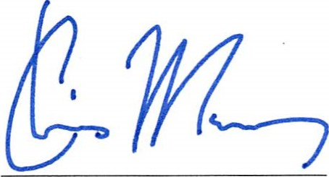 Sincerely,

|  |  |
| --- | --- |
| Christopher S. Murphy | Michael F. Bennet |
| United States Senator | United States Senator |

|  |  |
| --- | --- |
| Richard Blumenthal | Sherrod Brown |
| United States Senator | United States Senator |

|  |  |
| --- | --- |
|  |  |
|
| amm | aldwin |

|  |  |
| --- | --- |
| United tates Senator | United States Senator |

Kirsten Gillibrand



Debbie

|  |  |
| --- | --- |
| United States Senator | United States Senator |

# bill DLL/

Bill Nelson Cory A. Booker

United States Senator United States Senator Robert P. Casey, Jr. 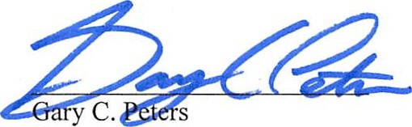

|  |  |
| --- | --- |
| Benjamin L. Cardin | Bernard Sanders |
| United States Senator | United States Senator |

United States Senator United States Senator

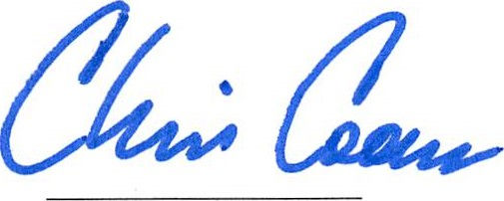Christopher A. Coons

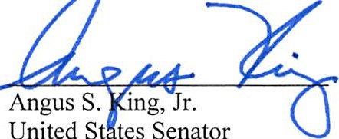

United

S

tes

Senator

United States Senator

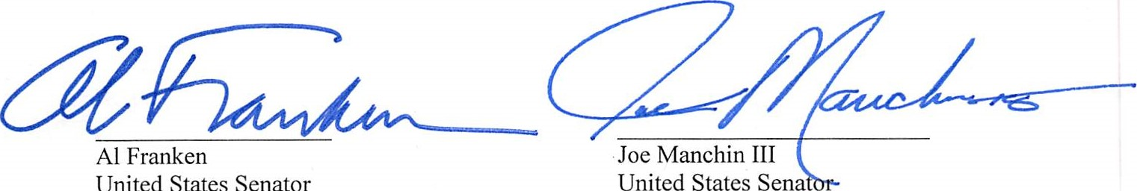

United

States

Senator

United

States

Sena

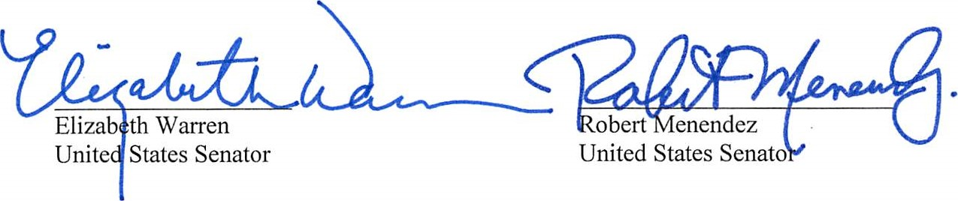Ron Wyden 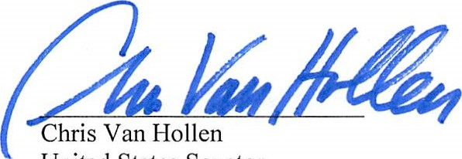Chris Van Hollen

United States Senator United States Senator

