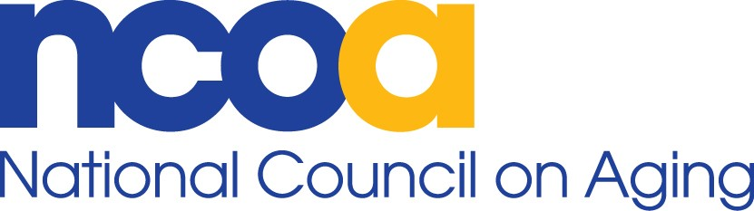

Issue Brief

Funding for Medicare State Health Insurance Assistance Programs (SHIPs)

Understanding the A, B, C, and Ds of Medicare is an overwhelming, isolating experience if older adults and people with disabilities go without help. SHIPs provide local, in-depth, insurance counseling and assistance to Medicare beneficiaries, their families and caregivers. This encompasses a broad range of areas, including coverage options, fraud and abuse issues, billing problems, appeal rights, and enrollment in low-income protection programs.

If the current $52.1 million investment had simply kept pace with inflation and the increasing number of Medicare beneficiaries since FY11, it would have reached at least $67 million for FY18. Cutting the program would be a devastating blow to the Americans with Medicare who would no longer have access to the only federal program that provides free, personalized, unbiased counseling on the growing complexities of Medicare coverage.

SHIPs receive funding through the Administration for Community Living for 54 grantees (all states, Puerto Rico, Guam, DC, and the US Virgin Islands), overseeing a network of more than 3,300 local SHIPs and over 15,000 counselors, 57% of whom are highly trained volunteers who donate almost 2 million hours of assistance.

Approximately 10,000 Americans become eligible for Medicare each day – significantly increasing the need for SHIP services. Over the past 2 years, about 7 million people with Medicare received help from SHIPs. Since 1992, counseling services have been provided via telephone, one-on-one in-person sessions, interactive presentation events, exhibits and health fairs. Individualized assistance provided by SHIPs almost tripled over the past 10 years.

SHIPs advise, educate, and empower individuals to navigate the increasingly complex Medicare program and help beneficiaries make choices among a vast array of options to best meet their needs. Making informed decisions among an average of 20+ prescription drug plans and 19 Medicare Advantage plans, as well as various Medigap supplemental insurance policies, can save money and improve access to quality care. Given the significant differences in premiums, cost sharing, provider networks, and coverage rules, SHIPs play a critical role in ensuring that these choices are well informed and thoughtful for each beneficiary served.

While the Medicare coverage that best meets a beneficiary’s unique needs isn’t always the least expensive, wise decision-making by informed consumers in the current market can save money for individuals, and potentially reduce overall Medicare spending as well. For example, a 2012 study in Health Affairs entitled “The Vast Majority of Medicare Part D Beneficiaries Still Don’t Choose the Cheapest Plans That Meet Their Medication Needs,” found that if beneficiaries chose the least expensive Part D plan available in their region, they could save an average of $368 per year and that only 5.2% of the beneficiaries in the study sample chose the least expensive plan. Several states that estimate savings to beneficiaries resulting from SHIP assistance reported achieving significant savings in 2015, including $110 million in Massachusetts, $56 million in Michigan, and $53 million in North Carolina.

SHIPs offer increasingly critical services that cannot be supplied by 1-800 MEDICARE, on-line or written materials, or other outreach activities. In fact, approximately one-third of all partner referrals to SHIP originate from Medicare Advantage and Part D prescription drug plans, local and state agencies, the Centers for Medicare and Medicaid Services, the Social Security Administration, and members of Congress and their staff. Additionally, these partners include SHIP contact information in their websites, publications, and correspondence to beneficiaries as the source of assistance when individuals need help.

July 2017

NCOA Public Policy & Advocacy ▪ 251 18th Street South, Suite 500 ▪ Arlington, VA 22202 ▪ advocacy@ncoa.org