**SUPPLEMENTAL SECURITY INCOME**

*The Leadership Council of Aging Organizations (LCAO) is a coalition of national not-for-profit organizations representing the interests of 60 million older Americans.*

**SSI OVERVIEW**

Supplemental Security Income (SSI) is a federal program that provides *income assistance* for over 8 million older Americans as well as children and adults with disabilities in deep poverty. The 2018 monthly maximum federal SSI payment is $750 for an individual and $1,125 for a couple. This equals about $25 per day. SSI was signed into law by President Nixon in 1972. He described the program as one that would “mean a big step out of poverty.” In reality, SSI cash benefits fall short of federal poverty guidelines.

|  |  |  |
| --- | --- | --- |
| **$25 per day** | **2.2 million seniors** | **6 million children & adults with disabilities** |

**STRENGTHENING SSI**

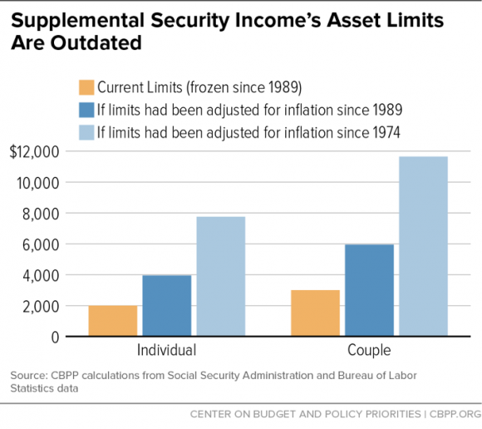There are several ways the SSI Program could be strengthened. SSI benefits were last modernized to meet inflation levels nearly 30 years ago. [1] Today’s SSI requirements are outdated, and adversely effecting its recipients. Americans who receive SSI are limited to saving $2,000 ($3,000 for a couple). This can prevent saving for emergency situations, like necessary home and car repairs. SSI benefits are also significantly reduced when a recipient receives non-employment income over $20 a month, or earned income over $65. This means a recipient who already has an extremely low income is forced to remain below the poverty level, even if they have other sources of income, like Social Security retirement benefits. Another challenge for SSI recipients is the “in-kind support and maintenance provision,” which reduces SSI benefits when a person receives certain free or reduced rate food and shelter. This means that recipients cannot receive assistance of food or shelter from family members without losing a significant portion of their benefits. This provision also creates a significant administrative burden on the Social Security Administration, which must determine the value of the food and shelter provided.

**WHAT CONGRESS CAN DO**

Congress should pass the “Supplemental Security Income Restoration Act of 2017.” The bill would provide some sorely needed updates to this long-neglected program. SSI resources limits would increase from $2,000 to $10,000.

The current resource limits create cycles of poverty, eliminating any chance of financial independence as people are unable to save enough to cover life expenses, like dental care, car repairs, or a broken furnace. The SSI Restoration Act of 2017 would increase the SSI resource limit, and update the General Income Disregard, and Earned Income Disregard that severely reduce SSI benefits when a person has any other sources of income. The bill also prevents the reduction of benefits for the receipt of in-kind support.

SSI is a minute part of the overall federal budget and its expense is beginning to decrease. The cost of SSI is expected to continue to decrease as a percentage of GDP over the next decade, making it an even more affordable program to help the most vulnerable groups in the United States.

1. Graph: https://www.cbpp.org/research/social-security/policy-basics-supplemental-security-income