**BenefitsCheckUp – Browser recommendation for performing multiple screenings**

BenefitsCheckUp now supports durable local browser storage to give users added flexibility in how they navigate BCU. While this allows an improved user experience for most users, counselors and other individuals who run multiple screenings a day on behalf of other individuals may experience a carry-over of data from one screening to the next.

Recommendation: To cleanly delineate one screening from the next, we recommend performing each screening in a new “Incognito” or “(In)Private” window. Below are the steps to do so:

1. Open a new “Incognito” or “(In)Private” browser window for each session:
   * In Google Chrome, this can be done by selecting “Ctrl + Shift + N” on your keyboard or navigating to the following location in your browser:

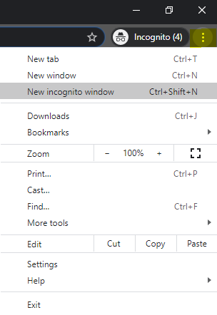

*Navigate to the top right of the browser, click the three vertical dots, and select “New incognito window*

* + In Firefox, a private window can be launched by entering “Ctrl + Shift + P” on your keyboard or by selecting the following:

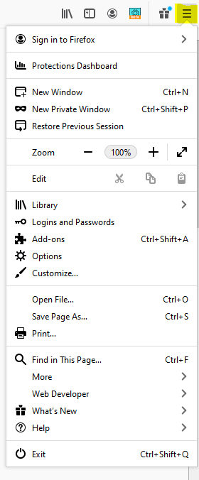

*Navigate to the top-right corner of the browser, select the three horizontal bars, and select “New Private Window”.*

* + In Microsoft Edge, you can launch an InPrivate window by selecting “Ctrl + Shift + N” or navigate to the top right of the browser as with the other browsers:

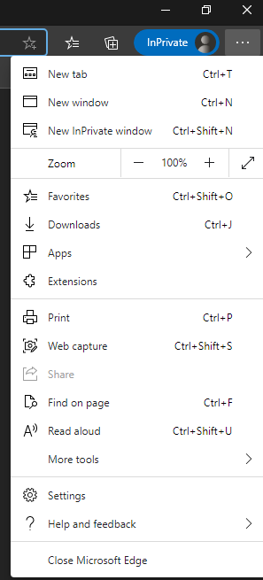

1. Following the conclusion of a screening session, fully close the window.

Repeat for each subsequent screening.