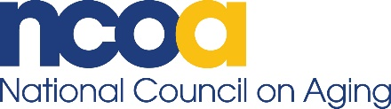

Contact
Armando Trull
Media Relations Manager
202-709-2474
armando.trull@ncoa.org

NCOA Selects New CEO
Ramsey Alwin returns to National Council on Aging

Arlington, VA (June 17, 2020) – The National Council on Aging (NCOA) announced today that Ramsey Alwin has been named the organization’s new chief executive officer effective Aug. 31. Alwin replaces James Firman, who led NCOA for 25 years until his retirement earlier this year. Alwin is an experienced public policy leader with a demonstrated passion and commitment to addressing issues related to aging in America. She returns to NCOA following five years at AARP.

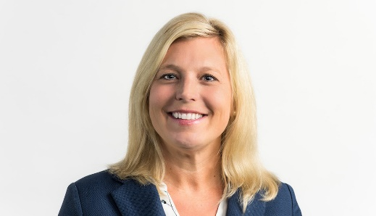
“Ramsey has a vision for the organization’s future and innovative ideas for how we can grow NCOA and the scope of its impact,” said James Knickman, chairman of NCOA’s Board of Directors. “More importantly, she understands the DNA of the organization. We met an ambitious goal of improving the lives of 10 million older adults by 2020, a goal that we met one year early. Under Ramsey’s leadership, we will aim to improve the lives of 40 million older adults by 2030.”

Alwin is very familiar with NCOA, having served as vice president, economic security for the organization from 2009 to 2015. During this time, she oversaw the development and implementation of programs designed to promote the economic security of older adults and developed and secured funding for a holistic economic assistance program for older adults during the last economic recession. She joined AARP in 2016 as director, Global Thought Leadership – Financial Resilience.

“I am thrilled to return to NCOA to lead our team into the organization’s next chapter of social impact, accelerating reach and broadening impact to help older adults age with dignity,” said Alwin. “NCOA leads the way as a champion for the health and economic security of older adults. Everyone deserves the opportunity to age well.”

Alwin was inspired to pursue a career in public policy while student teaching in Boston’s public schools. Seeing the socioeconomic issues that affected her students convinced her that she could have greater impact by working to bring about changes to systems and policies than teaching in a single classroom.

Prior to her initial role at NCOA, Alwin served as director, National Economic Security Programs for Wider Opportunities for Women (WOW) and held several roles within the National Association for State Community Services Programs, most recently, director of program services. She holds a bachelor’s degree in secondary education and sociology from Simmons College in Boston and an executive master’s degree in leadership from Georgetown University’s McDonough School of Business.

Alwin’s social channels include LinkedIn and Twitter.

About NCOA
The National Council on Aging (NCOA) is a trusted national leader working to ensure that every person can age well. Since 1950, our mission has not changed: Improve the lives of millions of older adults, especially those who are struggling. NCOA empowers people with the best solutions to improve their own health and economic security—and we strengthen government programs that we all depend on as we age. Every year, millions of people use our signature programs BenefitsCheckUp®, My Medicare Matters®, and the Aging Mastery Program® to age well. By offering online tools and collaborating with a nationwide network of partners, NCOA is working to improve the lives of 40 million older adults by 2030. Learn more at www.ncoa.org and @NCOAging.

