Dear BEC Lead,

NCOA’s national annual conference, Age+Action, will take place virtually this year from June 6-8.

Registration is now open for the conference, and as in years’ past, you should have budgeted participation of at least one member of your staff to attend, though you are certainly welcome to register more.

To register:

1. Visit [www.ageaction.org](http://www.ageaction.org) by clicking “Register Today” and “New Registration”

On this page, enter your email (double-check for typos!) and click the second button to indicate your registration under the Center for Benefits Access:

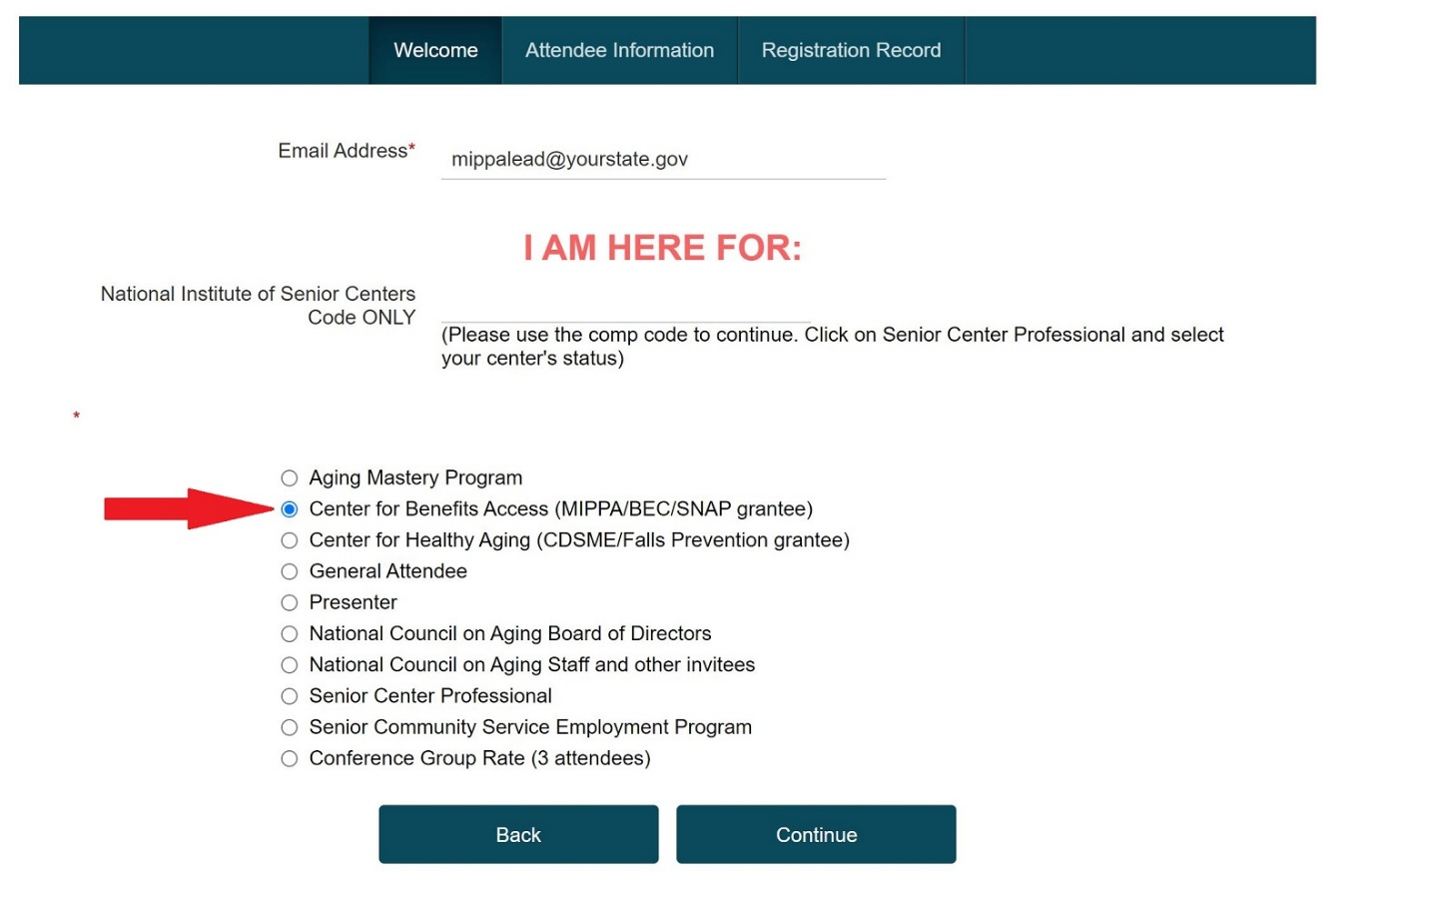

Do not enter anything into the blank field for National Institute of Senior Centers. Leave blank!

1. On the following page, click the first bullet for **BEC Grantee**

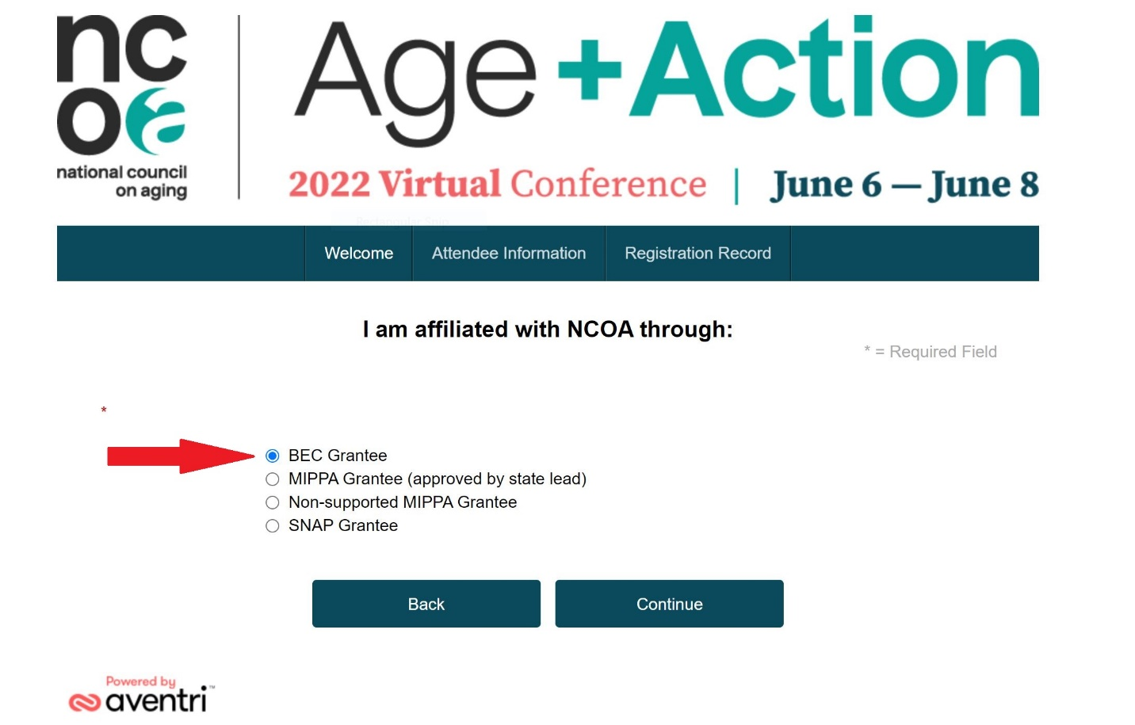

1. Follow instructions to complete registration and payment. (Payment may be made by check; see portal or contact your BEC project officer at NCOA for more information.)
2. You will receive a registration confirmation email; if you do not, please email [conference@ncoa.org](mailto:conference@ncoa.org).

If you intend to register 3+ people at a discounted rate, you’ll want to select Conference Group Rate on the registration homepage.

We look forward to “seeing” you in June!